Earlham Volleyball Club Tournament – March 2nd and 3rd, 2024
February 2nd – 14U
February 3rd – 15U

Facility Location & Rules:
- Earlham Community Schools – 535 N. Chestnut, Earlham, IA 50072
- Admissions for spectators will be $5 for adults, $3 for students and seniors, and free for ages 5 and under. Players and coaches are admitted free.
- There is a full-service concession stand available at this tournament. No plug-in appliances allowed.
- No food will be allowed on the playing court or at the score tables.
- There will be bleachers and chairs for spectators. No outside chairs are allowed in the gyms.
See below for map of the school and parking. 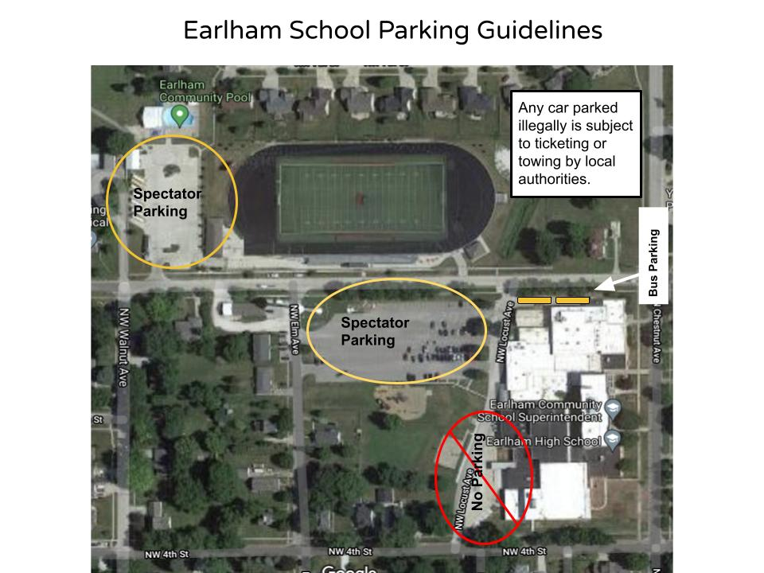.

Coaches:
- Check in 20 minutes prior to game time.
- Please bring a signed copy of your roster to the tournament or email it to the club director.
- Please help games start on time to ensure the tournament runs smoothly.
- Matches will be played ahead of schedule as dictated by play.
- Teams should provide their own warm-up balls.

Tournament Format
Pool Play:
- Pool play begins at 8:00 a.m. – Doors open at 7:15 a.m.
- Two games to 21, win by two, no cap; Games will start at 0-0. If teams split, no third game will be played.
- Warm-up protocol for the 1st match: 2 minutes shared court – 4 minutes individual court for each team.
- Warm up for all other matches – 3 minutes individual court for each team.
- Captain’s meeting immediately following the preceding game.
- Officiating team is responsible for keeping matches running on time. At the discretion of the court manager, if matches do not start promptly, the officiating team can be docked a point per minute from the schedule match time or after the warm-up time has ended as defined in the rule book.
- There is supposed to be a 10-15 minute break for Team #1 to take before the 10:30 game and it is up to that team if they take the break.
Tournament Play – Single Elimination:
- Immediately following conclusion of play.
- Must win 2 of 3 games.
- Games 1 and 2 to 25 points. Game 3 to 15. Games will start at 0-0. Win by two – no cap.

Officiating:
- Each team must provide 2 officials, 1 scorekeeper, 1 libero tracker, and 2 line judges. A coach must be actively participating during bracket play, though they do not have to be R1.
- If a team misses their officiating match, it could result in a forfeit of the first game of their next match.

Seeding:
- Seeding for playoff position is determined by:
  - Overhead win/loss record by game
  - Head-to-head wins
  - Head-to-head point differential
  - Total round pool point differential
  - Coin toss

Awards:
- Medals will be awarded to the 1st place team in the Gold (upper) bracket.
- Medals will be awarded to the 1st place team in the Silver (lower) bracket.

If delayed by weather traveling to the tournament, PLEASE CALL Cameryn Caskey at 515-729-0442 as soon as possible!

